Pre Calc Name: ______________

______________ ______________

WS Assessment

Target 16

Trigonometry identities

* Basic Trigonometric Identities
* Simplifying Trigonometric Expressions
* Proving Trigonometric Identities
* Inverse Trigonometric Functions
* Solving Trigonometric Equations
* The Sum and Difference Identities
* Double-Angle Identities
* Other Advanced Identities

HW 16 Trig Identities deltamath.com

Graph this function y = sin3x + cos2x sin x. What do you notice? Explain

Fundamental Trigonometry Identities

Reciprocal Identities $\sin\left(θ\right)=\frac{1}{csc⁡(θ)}$ $\cos\left(θ\right)=\frac{1}{sec⁡(θ)}$ $\tan\left(θ\right)=\frac{1}{cot⁡(θ)}$

Quotient Identities $\tan\left(θ\right)=\frac{sin⁡(θ)}{cos⁡(θ)}$ $\cot\left(θ\right)=\frac{cos⁡(θ)}{sin⁡(θ)}$

Pythagorean Identities $\sin^{2}θ+\cos^{2}θ=1$ $\tan^{2}θ+1=\sec^{2}θ$ $\cot^{2}θ+{1= csc}^{2}θ$

Odd-Even Identities *sin(-x) = - sin(x) cos(-x) = cos(x) tan(-x) = - tan(x)*

Simplify the following

sin x – sin3x sin x tan x – sec x

tan x + cot x sin x + tan x cos x (csc x – sec x)sin x cos x

Factoring

1 + cos x – sin2x sec2x + tan x – 3 cos x + sec2x – tan2x

sin2x +sin2x tan x sin x – cos2x – 1 sec2x – sec x + tan2x

Confirm the identity by graphically (show graph or table) and algebraically

$\frac{(1-\cos{x)(1+\cos{x)}}}{\cos^{2}x}$ = $\tan^{2}x$ $2\cot{x\csc{x= \frac{1}{\sec{x-1}}+\frac{1}{\sec{x+1}}}}$

$\frac{\cos{x}}{1-\sin{x}}=\frac{1+\sin{x}}{\cos{x}}$ $\frac{\cot^{2}x}{1+\csc{x}}=(\cot{x)(\sec{x-\tan{x)}}}$

Confirm the identity

sin2x cos5x = (sin2x – 2sin4x + sin6x) cos x tan4x = tan2x sec2x – tan2x

sin3x cos4x = (cos4x – cos6x) sin x csc4x cot x = csc2x (cot x + cot3x)

Solving Trig Equation

3tan2x – 1 = 0 cot x cox2x = .5 cot x

3sec2x – 4 = 0 2sin2x = 2 cos x

2sin2x – sin x – 1 = 0 2sin2 x + 3 cos x – 3 = 0

cos2x + 3 cos x – 1 = 0 3sin x – 2cos2x = 0

cos x + 1 = sin x csc x + cot x = 1

sec2x – 2tan x = 4 sec2x + tan x – 3 = 0

2cos2x – 5cos x + 2 = 0 2sin2x – 7 sin x + 3 = 0

2cos 3x – 1 = 0 $3\tan{\frac{x}{2}-1=0}$ 2sin 2x + 1 = 0

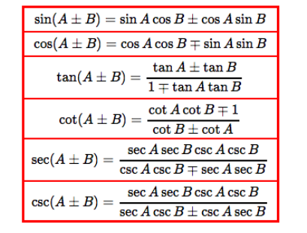

Find exact value of the following

sin(15o) cos(75o)

Find exact value

sin42o cos12o – cos42o sin12o cos15o cos60o + sin15o sin60o

Simplify

$\frac{\tan{{325}^{o}-}\tan{{86}^{o}}}{1+\tan{{325}^{o}\tan{{86}^{o}}}}$ sin 3 cos 1.2 – cos 3 sin 1.2 cos 3x cos 2y + sin 3x sin 2y

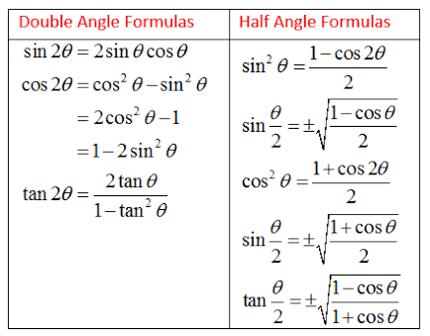Given cos x = 5/13. Find sin 2x, cos 2x, tan 2x

Given sin x = 4/5. Find sin 2x, cos 2x, tan 2x

Solve

2cos x + sin 2x = 0 4sin x cos x = 1 sin 2x sin x = cos x

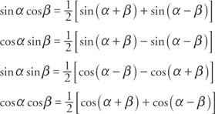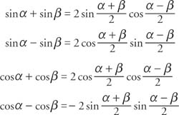

Solve

sin 5x + sin 3x = 0 sin 2x + cos 3x = 0 sin2x = 2sin2 x/2

Given a hexagon shape wire mesh length = a. Find the value of the angle x to maximize its area

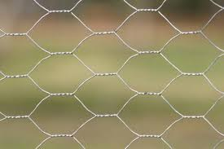

**Target 16 Assessment**

Confirm the identity

sin x + cos x cot x = csc x $\frac{\csc{x}}{1+\csc{x}}-\frac{\csc{x}}{1-\csc{x}}={2sec}^{2}x$

$\tan{x+ \frac{\cos{x}}{1+\sin{x}}=\sec{x}}$ $\frac{1+\cos{x}}{\cos{x}}$ = $\frac{\tan^{2}x}{\sec{x-1}}$

Solve trig equation

2cos 3x – 1 = 0 sec2x – 2tan x = 4

tan4x – 4tan2x + 3 = 0

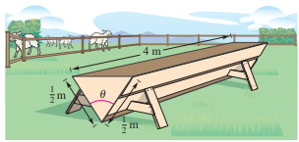

Given a trough for feeding cattle as shown. Find the value of the angle $θ$ to maximize its volume